

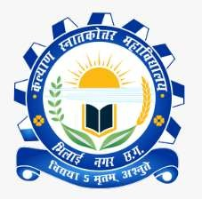Kalyan Post Graduate College

**Bhilai Nagar, District-Durg, Chhattisgarh, India**

Affiliated to Hemchand Yadav Vishwavidyalaya, Durg, Chhattisgarh

Phone : 0788-2284965 Email : [office@kalyanpgcollege.org](mailto:office@kalyanpgcollege.org) www : kalyanpgcollege.org

Criterion–II:Teaching-Learning andEvaluation

* 1. **Teaching-LearningProcess**
     1. *2.3.1- Student centric methods, such as experiential learning, participative learning and problem solving methodologies are used for*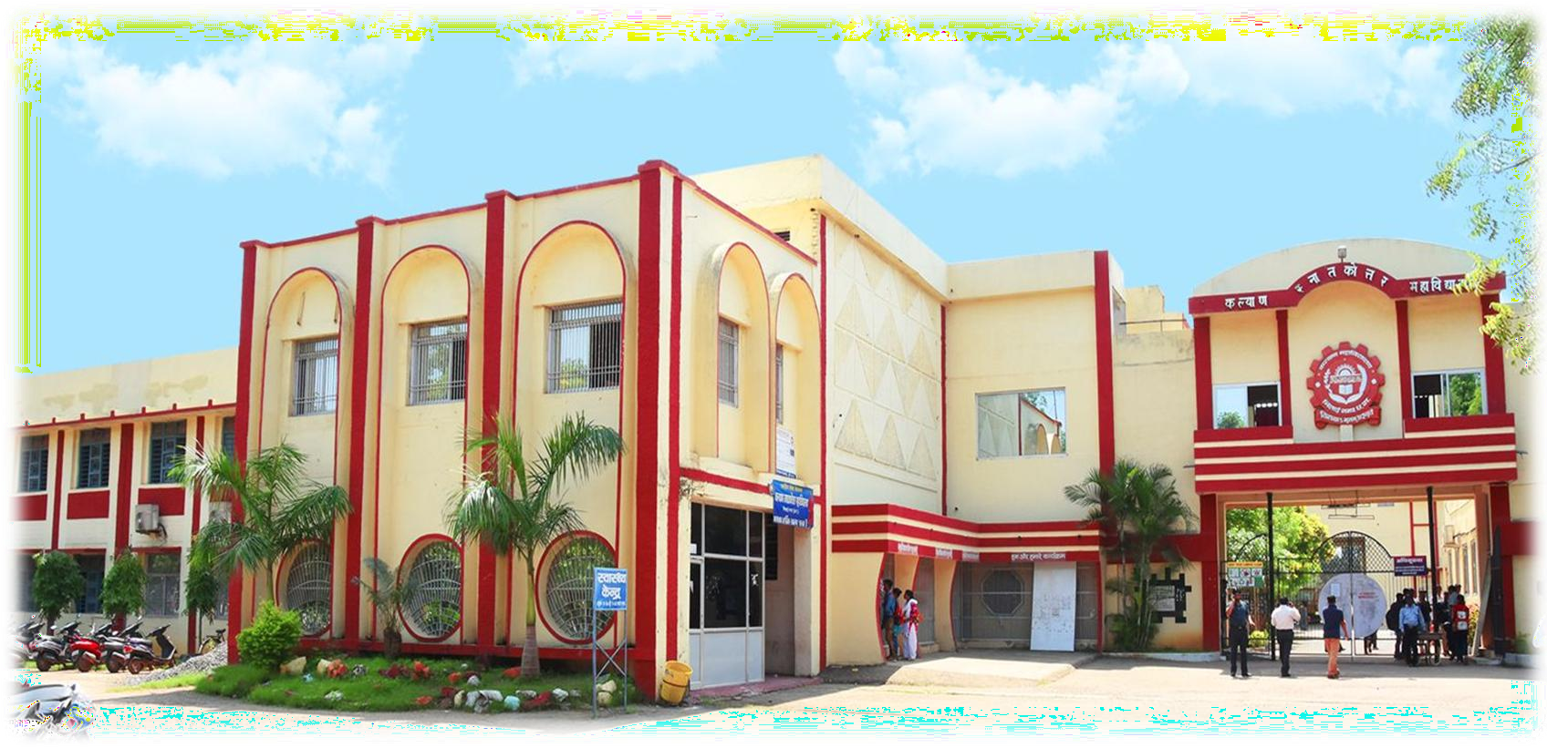Enhancinglearningexperiences

**Submitted to National Assessment and Accreditation Council**

**2021– 2022**

**2.3.1 Activities under experiential learning**



**Experiential learning involves learning through experiences “learning through reflection on doing”**

|  |  |  |  |
| --- | --- | --- | --- |
| **S.No.** | **Activity** | **ShortDescription** | **Pic/Document** |
| 1. | Internships Activities | Five month internship by B.ED. traineesin Government Schools of C.G.(Schools list provided by DEO) . |  |
|  | 1. School Teaching | Prepare lesson plans for teaching.Trainees get hand on experience. |  |
|  | (b) Observation of peer group | Trainees observe peer teaching and provide feedback on their teaching |  |
|  | (c ) Conducting  Social work | Engaging in social work with a community offers hands- on experiences that can't be replicated in a classroom. It provides real-life situations that challenge individuals to apply theoretical knowledge to practical scenarios.Thisexperiential learning fosters empathy, problem-solving skills, cultural understanding, and adaptability, enhancing personal and professional growth of students. |  |
|  | (d) Preparing Reflective Diary | Trainees Prepare various Report by interacting with school students/ teaching and non teaching staffs, prepare report on various school records |  |
|  | (e) Conducting action research | B.Ed trainees are encouraged to carry out action research on school related issues | Under Internship Activities |
|  | (f) Case Studies | B.Ed. trainees carried out case studies on educational issues/special children. | Under Internship Activities |
|  | (g) Teaching aid preparation | Students prepare models/charts in their respective pedagogies. |  |
|  | (h) Micro Teaching | Micro-Teaching is conducted for trainees before internship in which they practice various teaching skills like questioning, usage of ICT etc.  Micro-Teaching formats for skills is provided. |  |
| 2 | School Observation by M.ed./B.ed. students | M.Ed/BEd students visit Government schools for School observation they are provided with formats. |  |
| 3 | Dissertation (Short term research work) | MA (Sociology) and M.Ed students carry out shortterm research on socially relevant topics. |  |
| 2 | Projects  (a)Environment Project | Mandatoryforallfirst year under graduation students.As per university syllabus. |  |
|  | 1. OtherProjects | ByM.Sc.  (Biotech.) Students. |  |
| 3 | Skill development activities by departments | ﻿Skill development activities in college contribute significantly to Experiential learning by providing  hands-on, practical experiences. They offer a direct application of  theoretical knowledge acquired in classrooms, allowing students to engage actively, experiment, and  learn through experience. These activities often involve Simulations, Internships,  Projects, and workshops, enabling students to develop and refine their skills in real-world contexts, fostering a deeper understanding of concepts and enhancing  their abilities beyond theoretical  standing.  Various departments conducted many , competition on craft making, salad decoration, essay writing, debate, quizzes to promote development of various skills in students. Examples are provided in the link. |  |



|  |  |  |  |
| --- | --- | --- | --- |
| 4. | Community Survey and Sensitization | Students conduct community survey in villages and prepare report on Education/Health Economics sources etc. They also do school teaching, school beautification, gives cultural program, provide awareness regarding diseases, Vaccination awareness etc. Visiting specialchildrens’ school can offer a rich learning experience by fostering empathy, understanding, diverse needs and education. |  |
| 5. | News analysis / Report writing | Students enrolled in BAJMC deals with news analysis, Editing and Report writing. | Projects are also done by students |
| 6. | Fieldtrips/Excursions. | ﻿Field tours are incredibly beneficial for experiential  learning in college. They offer hands-on experiencesthat complement theoretical knowledge gained inclassrooms. They provide  real-world context, allowing students to see the practical  applications of what they're  learning, fostering a deeper understanding of concepts.  Field tours also encourage  critical thinking,  problem-solving, and  engagement by immersing students in environment where they directly apply their practical knowledge. |  |
| 7. | Laboratory experiences of science students and Education students. | →Students verify facts/law with the help of experiments.  →B.Ed / M.Ed. trainees conduct Psychology practicals |  |
| 8. | Educational activities by Home Science Students. | First aid box preparation, Diet Chart Preparation etc | Food item preparation is also done. |



|  |  |  |  |
| --- | --- | --- | --- |
| 9. | Seminar presentations | ﻿Seminars covers a wide range of topics, from hands-on teaching methods to learning experiences. They often focus on active participation, real-world applications, and reflection as integral parts of the learning process. Additionally, seminars often invite Guest speakers who share their experiences and insights, further enriching the learning process by connecting theoretical concepts to their practical use in various fields. |  |
| 10. | Publication of departmental magazines, news letters. | Students contribute their contents for departmental magazines and news letters. |  |

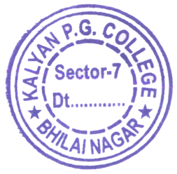 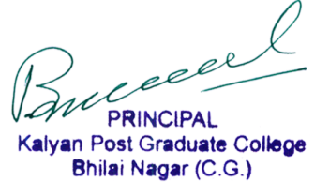



**ACTIVITIESUNDERPARTICIPATIVE/COLLABORATIVELEARNING**

|  |  |  |  |
| --- | --- | --- | --- |
| **S.No.** | **NameofActivity** | **ShortDescription** | **Proof** |
| 1. | WallMagazineActivities | Student group are formed for wall magazine activities in department. They display articles / Pictures concerning health / educational, national and International issues. |  |
| 2. | Activities of various committees under student union | Student union in collaboration with various departments performs varied activities involving worthful contribution towards society andinstitution. |  |
|  |  | **Tree Plantation by English Department and NSS**  **(25/ 09/2021)**  The aim of the event was to promote environmental awareness, combat climate change, and enhance the local ecosystem by planting trees. Participants included teachers , eminent dignitaries of the community and volunteers from NSS. | **C:\Users\b015991\Downloads\WhatsApp Image 2023-10-28 at 11.09.46 AM.jpeg** |
| 3. | Youthfestivals | Students participates in various events during youth festivals. Selected students represent college at university level. | As per COVID-19 guidelines |
| 4. | Activities of departmental Societies | * Every department has departmental society which conducts various activities. * Botany Departmental Society conducted   Quiz Contest   * English department students has started honest stationary. * Mathematics Department :-   Competitions were organized  by Maths Department Society. |  |
| 5. | National Organization like NCC / NSS activities | Cadets participated in various social activities, promoting government flagship programs, attended state and national level camps, represented in RDC/TSC etc. |  |
| 6. | Sports Activities | Institution organizes annual sports day in which students give their participations in individual and group level events. Interdepartmental sports events are  alsoorganized. | sports activities as per COVID-19 guidelines |
| 7. | Weekly cultural activities | Students groups (B.Ed.) are formed for weekly culture activities. Each group is allotted program to be conducted like Folk Dance, Folk Song, Dramas etc. The culture events are organized by trainees under the guidance of group incharges. It promotes participative learning. |  |
| 8. | Group allotted for prayer conduction | Students groups are formed for prayer conduction in education department. It involves reciting of prayer, performing yoga for five minutes, thought presentation, news reading and apprising studentsregardinglatest  notifications. | Conducted in every day in B.Ed. seminar hall. |
| 9. | Celebration of National State/regional festivals | Institution celebrates national festivals like Independence day, Republic day, State festival like Hareli, Navratri, Ganesh Utsav, Holi Milan etc. These events promotes participative learning. |  |



|  |  |  |  |
| --- | --- | --- | --- |
| 10. | Annual Function | Students participates in cultural events and helps in maintainingdiscipline, distribution of refreshment etc. | Annual Function as per COVID-19 guidelines |
| 11. | Celebration of Commemorative dates and festivals. | Celebration of Commemorative dates and festivals helps in  Cultural Immersion: Engaging in these celebrations exposes individuals to diverse customs, traditions, and histories, fostering a deeper understanding through direct experience.  Hands-on Activities: Participation often involves hands-on activities, such as crafts, performances, allowing individuals to actively engage and learn through doing.  Social Interaction: Interacting with others during these celebrations promotes social learning, encouraging dialogues, sharing of stories, and cultural exchange among participants.  Contextual Understanding: Experiencing the festivities firsthand provides a contextual framework, enabling a more profound comprehension of historical events, societal values, and their significance.  Emotional Connection: Personal involvement in these celebrations fosters an emotional connection, making learning more memorable, meaningful, and impactful for individuals, creating lasting impressions and deeper insights. |  |

 

